EXPERIMENT-8
8. A game AI needs to make faster decisions by avoiding unnecessary game-tree exploration. Implement Alpha-Beta Pruning. Reduce search time while preserving optimal decisions.

PROGRAM:
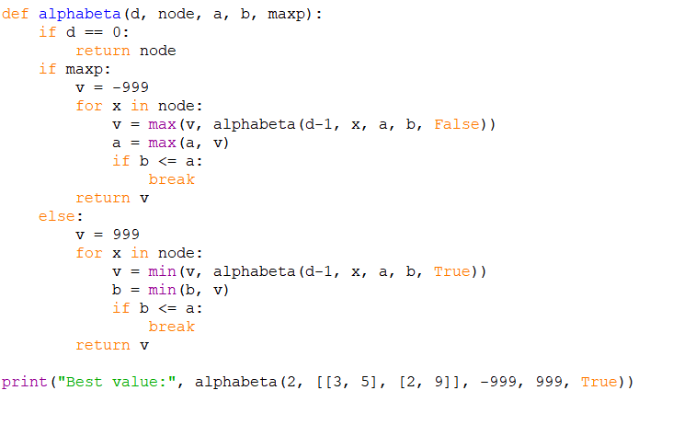

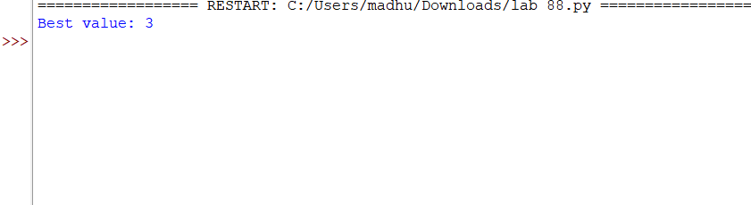
OUTPUT:

